

**School of Public Administration  
Bachelor of Science in Computing**

**COMP407 Selected Topics II – IT Solutions for Business  
Final Report**2014/15 1st semester

|  |  |
| --- | --- |
| SugarCRM Improvement System | |
|  |  |
| Team number: | 3 |
| Team members: | Athena HOI Ka Wai (P1104463)  Sandy CHEN Wan Ping (P1107936)KeyLIANG Yi Juan (P1107923) |
|  |  |
| Supervisor: | Dr. Benjiman Ng |
| Assessor: | Dr. Rita Tse |
|  |  |
| Submission Date: | Nov 17, 2014 |

**Table of Contents**

[1 Introduction 4](#_Toc399382214)

[1.1 Overview 4](#_Toc399382215)

[1.2 Objectives 4](#_Toc399382216)

[2 Background 5](#_Toc399382217)

[3 Methodology 8](#_Toc399382218)

[3.1 Requirement Elicitation 8](#_Toc399382219)

[3.1.1 Scenario for SugarCRM 8](#_Toc399382220)

[3.1.2 User Requirements 9](#_Toc399382221)

[3.2 Requirement Specification 10](#_Toc399382222)

[3.2.1 Functional requirements 10](#_Toc399382223)

[3.2.2 Non-functional requirements 11](#_Toc399382224)

[3.2.3 Domain requirements 12](#_Toc399382225)

[4 System Implementation 13](#_Toc399382226)

[4.1 Architecture 13](#_Toc399382227)

[4.2 Data Modelling 13](#_Toc399382228)

[4.2.1 Identifying entity type 13](#_Toc399382229)

[4.3 Enhancement to existing system 15](#_Toc399382230)

[4.4 Key problems and their solutions 15](#_Toc399382231)

[5 Results and discussion 16](#_Toc399382232)

[5.1 Project Outcome 16](#_Toc399382233)

[5.2 System evaluation 17](#_Toc399382234)

[Appendix 18](#_Toc399382235)

[Project plan 18](#_Toc399382236)

[Refernces 19](#_Toc399382237)

[Peer Assessment Form 20](#_Toc399382238)

# Introduction

## Overview

As the LT Game Company continues to develop, the quantity of business transactions and corresponding interactions with customers will become larger. Consequently, a customer relationship management system is of the greatest necessity and importance for the company. The general aim of this project is to improve the SugarCRM system of LT Game Company.

## Objectives

* Get the information of the company and identify the problems in their IT system.
* Identify the requirement of the IT system.
* Proposed an improved CRM system that satisfies the requirements.
* Make the utilization of the system in the staffs reach 90%.

# Background

LT Game is one of the major gaming and casino providers in Macau and in the Asia Pacific region. The products mainly include the Live Multiple Games System (Which has live dealers, supports multiple table and has a terminal-based multi-game selection system) and the Paradise Jackpot System (Baccarat Side-Bet Progressive Jackpot). Both have been patented in Macau, USA and PCT (Patent Cooperation Treaty) countries. LT Game is striving to be at the forefront of the global gaming industry. Live Multiple Game System provides first-rate live table gaming and is unparalleled in the electronic gaming world. The Live Multiple Games machines include Live Baccarat, Live Roulette, Live Sicbo, Live Blackjack, Live SanGong and Live Keno. The Paradise Jackpot is a patent granted Baccarat-based progressive jackpot. By linking up the side bet on the felt tables, players will be able to participate in the progressive jackpot in accordance to the DICJ’s (Macau Gaming Board) approved betting payout. Paradise Jackpot System is designed to be a cross-casino and cross-table system, it allows the jackpot pool size to increase in a rapid and enthralling rate.

The following is organizational structure of LT Game

CEO

Sales Admin

COO

IT Manager

Senior Manager

Project Manager

DB/System Engineer

Network Engineer

Potential Senior Technician

Assistant Technician Manager

Technician

Senior Technician

Potential Senior Technician

Technician

According to the organization structure of LT Game, before the plans of changing in functions are admitted, the technician would discuss and deliver the plans to potential senior technician, if the senior technician thinks the plans are valuable, and then he/she would deliver the cases to the DB/System engineer. After that the DB/System engineer, project manager and COO will have a meeting to discuss the plans. If it goes well, the plans would be executed.

There are many kinds of issues in marketing, sales, customer service and technical service. It’s hard to integrate the information without a customer relationship management (CRM) system. For example, there are lots of after-sale services in the LT Game, CRM system could track every service until it solved. A quality customer relationship management system can help us organize, automate and synchronize well the information, improve the efficiency, thus makes profit for company. It also enables the company to obtain business dealings with customers in a more systematic way in the market

SugarCRM is a customer relationship management (CRM) system that is available in both open-source and Commercial open-source applications. It enables businesses to create extraordinary customer relationships with the most innovative and affordable CRM solution in the market. It has a flexible management system and perfect IT equipment management function, which makes the process of managing customer relationships systematically. It is not only a management system, but also allows the users to know the solutions for sales. So that customers can trust us more. As a result, SugarCRM software can enhance the competitiveness of the enterprise and service quality.

The popular company IBM, has chosen SugarCRM for its lucrative CRM contract. In February 2012, Blytheco similarly chose to end its 30-year relationship with Sage in favor of SugarCRM.

# Methodology

## Requirement Elicitation

For gathering information of user requirements for improving SugarCRM system, we arranged Athena to go to the company and spent 3 months to take part in the operation and gain experiment of using it. The following information is found via work experience on an internship in LTGame.

### Scenario for SugarCRM

Each companies have their own operation procedure. This part will show the real-life of how SugarCRM be used in LTGame routine work.

#### Initial assumption

There are three situation will create a case. First, when floor manager finished the routine inspection, he/she would write a excel document for bad machine. Second, floor manager also would make a phone call for the IT support. Reporting some machine have problem. Third, some big cooperation plan also will be created by manager in LT Game in the system.

#### Normal

Every afternoon when received the routine inspection report. The data entry operator will entry the bad machine as a case into the system and assigned to assistant technician manager. In addition, he/she will compare the case in the system and the routine inspection report. Finding the relative machine have been maintained or not. If the machine was completed, the status of case will be changed to close. On the other hands, the big case will be updated when it has new resolution.

#### What can go wrong

The data entry operator can’t find the relative case in the system. However, some cases also lose tracking. For example, a case is reported by routine inspection report without any resolution. It doesn’t receive any maintenance form. In the following day, the relative case in the new routine inspection report will disappear.

#### Other activates

Everyone can edit the case which have been register before. Whereas the system will create the change log.

#### System state on completion

The case record is entered in the database and is added to the system log showing the create time with creator in the home page.

After using SugarCRM, the system is found some technical problem. On the other hands, improving the system into a better version and enable user in the company can use this system much more efficiency.

#### Search engine

The search engine just can search the first letter or word. If user wants to search the key word in a subject. It can’t be work.

Sometime it may want to find the machine for same special reason. When typing the key word such as hand pay, the system can’t find any result. Because of the subject name always name by machine number first.

#### Interface

It provides different department to use. But each account can see the same function in the interface.

Creating the user account for the staff. It should have different jurisdiction. When access the different staff account. The system will show the same usable functions.

#### Import/export

The system just can export the English word in case. If the tittle is Chinese word, it will show unreadable code However, if input some data in the system. You just can use its template. But I can’t see anyone try to follow the structure. Making easy to input the data.

Every day, each shift has a work sheet but the format or temple is different to the system. If the system can lead-in the document and updated the case’s status, it will save the input data time.

#### Create a client server

This system just can use in the sky office. Sometime IT department will receive the floor manager called. They said that there was betting terminal had problem. If they can directly put those problem in the system via the client side.

There is much maintenance received from the customer every day. They will have a phone call first. At that moment, it will have some missing point for communication.

#### Report function

The system doesn’t have any analyzing function. It can’t count the total of time that problem have been occurred before in a machine.

There are many machine have been constantly failure again and again. It can easy to analyze which machine has a big problem.

## Requirement Specification

The SugarCRM have a lot of functions with module. However, some special role of the operating in the IT department is related to the system specification. This section will show the requirement below which have been used in LTGame.

### Functional requirements

#### Create Account

This function is used to create a new account in the database. The name of each account are those cooperation casino’s name.

#### View Accounts

This function shell show all the accounts which have been created before. The editing is accepted normally.

#### Import Accounts

This function shell import account documents by using the system’s template or input the backup document.

#### Create Case

This function is used to create a new case in the database. The name of case is a cooperation project or bad machine.

#### View Cases

This function shell show all the cases which have been created before. The editing is accepted normally.

#### Import Cases

This function shell import case documents by using the system’s template or input the backup document.

#### Search Engine

Searching all the cases by option in the database. The option includes reference number of case, status, subjects, assigned to, account name and priority.

#### User Administration

This function shell change the user personal information and set up the jurisdiction.

#### Project function

This function shell create a new project type of case. That involves some special function such as schedule arrangement function.

### Non-functional requirements

* The CRM system shall be available to IT department on 24 hours every day.
* System response time shall not exceed two seconds without upload document.
* The database storage shall be more than 25GB.
* It provides two languages which are Chinese and English.(because of culture problem)
* Users of CRM system shall be IT support or floor manager.(register in the system first)
* The user name of an account is used the front of their e-mail address which is provided form the casino.
* When the IT support finished their maintenance work, they need to fill in a maintenance form which includes start time, finish time, reference number, content of work, confirmatory person, IT staff, status, etc.
* Through upload the form then close corresponding case.(only manager of the LTGame can check and update reports)
* The manager of LT Game, once the report is sent, no change is accepted.
* Providing a training course for the floor manager can increase the use efficiently. The manager of the casino should be forced to use this system with the order from their CEO. Any other forms of reports should not accept any more.
* The system server should have a maintenance each week. All the reports should be check in this maintenance.
* A report is not yet closed for a week, a warning should appear to alert the manager to change the status of the report to emergency in the beginning of the maintenance time.
* For not yet closed reports, an email should be send to both the manager of the LTGame. This maintenance should be done with a copy of all the reports in the server offline. Once all the reports are checked, update to the server process should be done within 2 minutes.
* System server should not shut down over 2 minutes including maintenance. If unexpected shut down happen, all the reports should be kept in the buffer of the client side. Once the system is recovery all the buffered report should be uploaded to the server automatically. Fail to send report due to the server shut down is not acceptable.

### Domain requirements

1. The CRM system (both server side and client side) shall run on windows os and mac os which are the most common personal computer platform.
2. Main using the web technology establishes this system. Therefore, it must have network connection in a computer.

# System Implementation

To implement the improved system, the project is going to rebuild the system.

## Platforms

To implement the CRM system, the PhpStorm would be used as the main development tool.

The server side, Apache will be used, and MySQL would be used as database side.

## 4.2 Architecture

The client-server web application follows MVC software design pattern.

Model

The model is the permanent storage of the data used in the overall process. It links the View component and the Control component. Its only purpose is to process data into its permanent storage.

View

The view is where data requested from database output to the users. It generates and displays HTML to the users. It also processes dynamic content.

Controller

The controller is to handle the users’ inputs and submit, and update the Model accordingly. When the users interact with View (such as submitting forms), and the functions of Controller would be triggered.

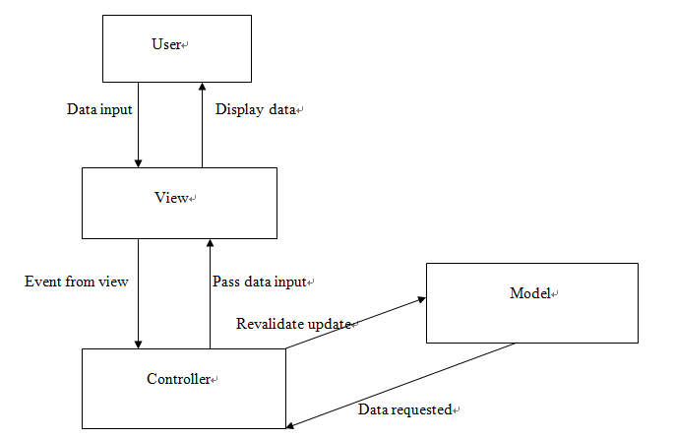

## Data Modelling

### Identifying entity type

|  |  |  |  |
| --- | --- | --- | --- |
| Entity name | Description | Aliases | Occurrence |
| Staff | General term describing all the staffs in the casinos who takes responsible of reporting machine problem and have registered the website. | floorManager | Each staff who has registered the website then will be able to report problems. . |
| Operator | General term describing the all the operators in the LT Game company who takes the responsibility of tracking and reporting the status of the machine problem. | Operator | Each operator who has registered the website then will be able to manage the post from the staffs in casinos. |
| Case | General term describing what problem the staff has reported, with the post status, which are pending, under solving, solved. | Post | Each post shows which staff reported it and the post status. |

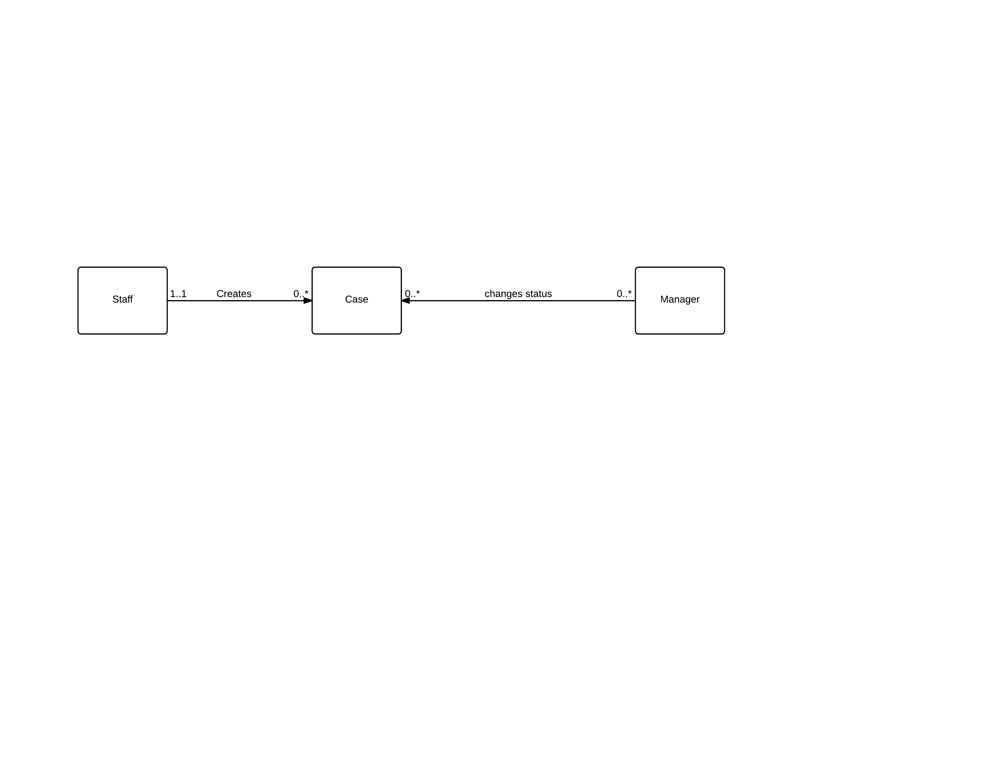

The following is the state diagram of the database schema

|  |  |  |  |  |  |
| --- | --- | --- | --- | --- | --- |
| Entity name | Attributes | Description | Data type &length | Nulls | Multi-valued |
| Staff | Email | Uniquely identity email of staff in casinos | 30 variable characters | No | No |
| Name | The name of staff | 15 variable characters | No | No |
| Company | The company of the staff | 50 variable characters | No | No |
| Password | Password for user verification | 6-16 characters and both number and character are required | No | No |
| Case | Subject | The subject of the post | 30 variable characters | No | No |
| description | The description of the post | 200 variable characters | No | No |
| PostDate | The date the staff that post the problem | Date | No | No |
| status | The problem of posts’ status | 15 variable characters | No | No |
| Operator | Email | Uniquely identity email of operator | 30 variable characters |  |  |
| Name | The name of operator | 15 variable characters |  |  |
| Password | Password for operator verification | 6-16 characters and both number and character are required | No | No |

UML diagram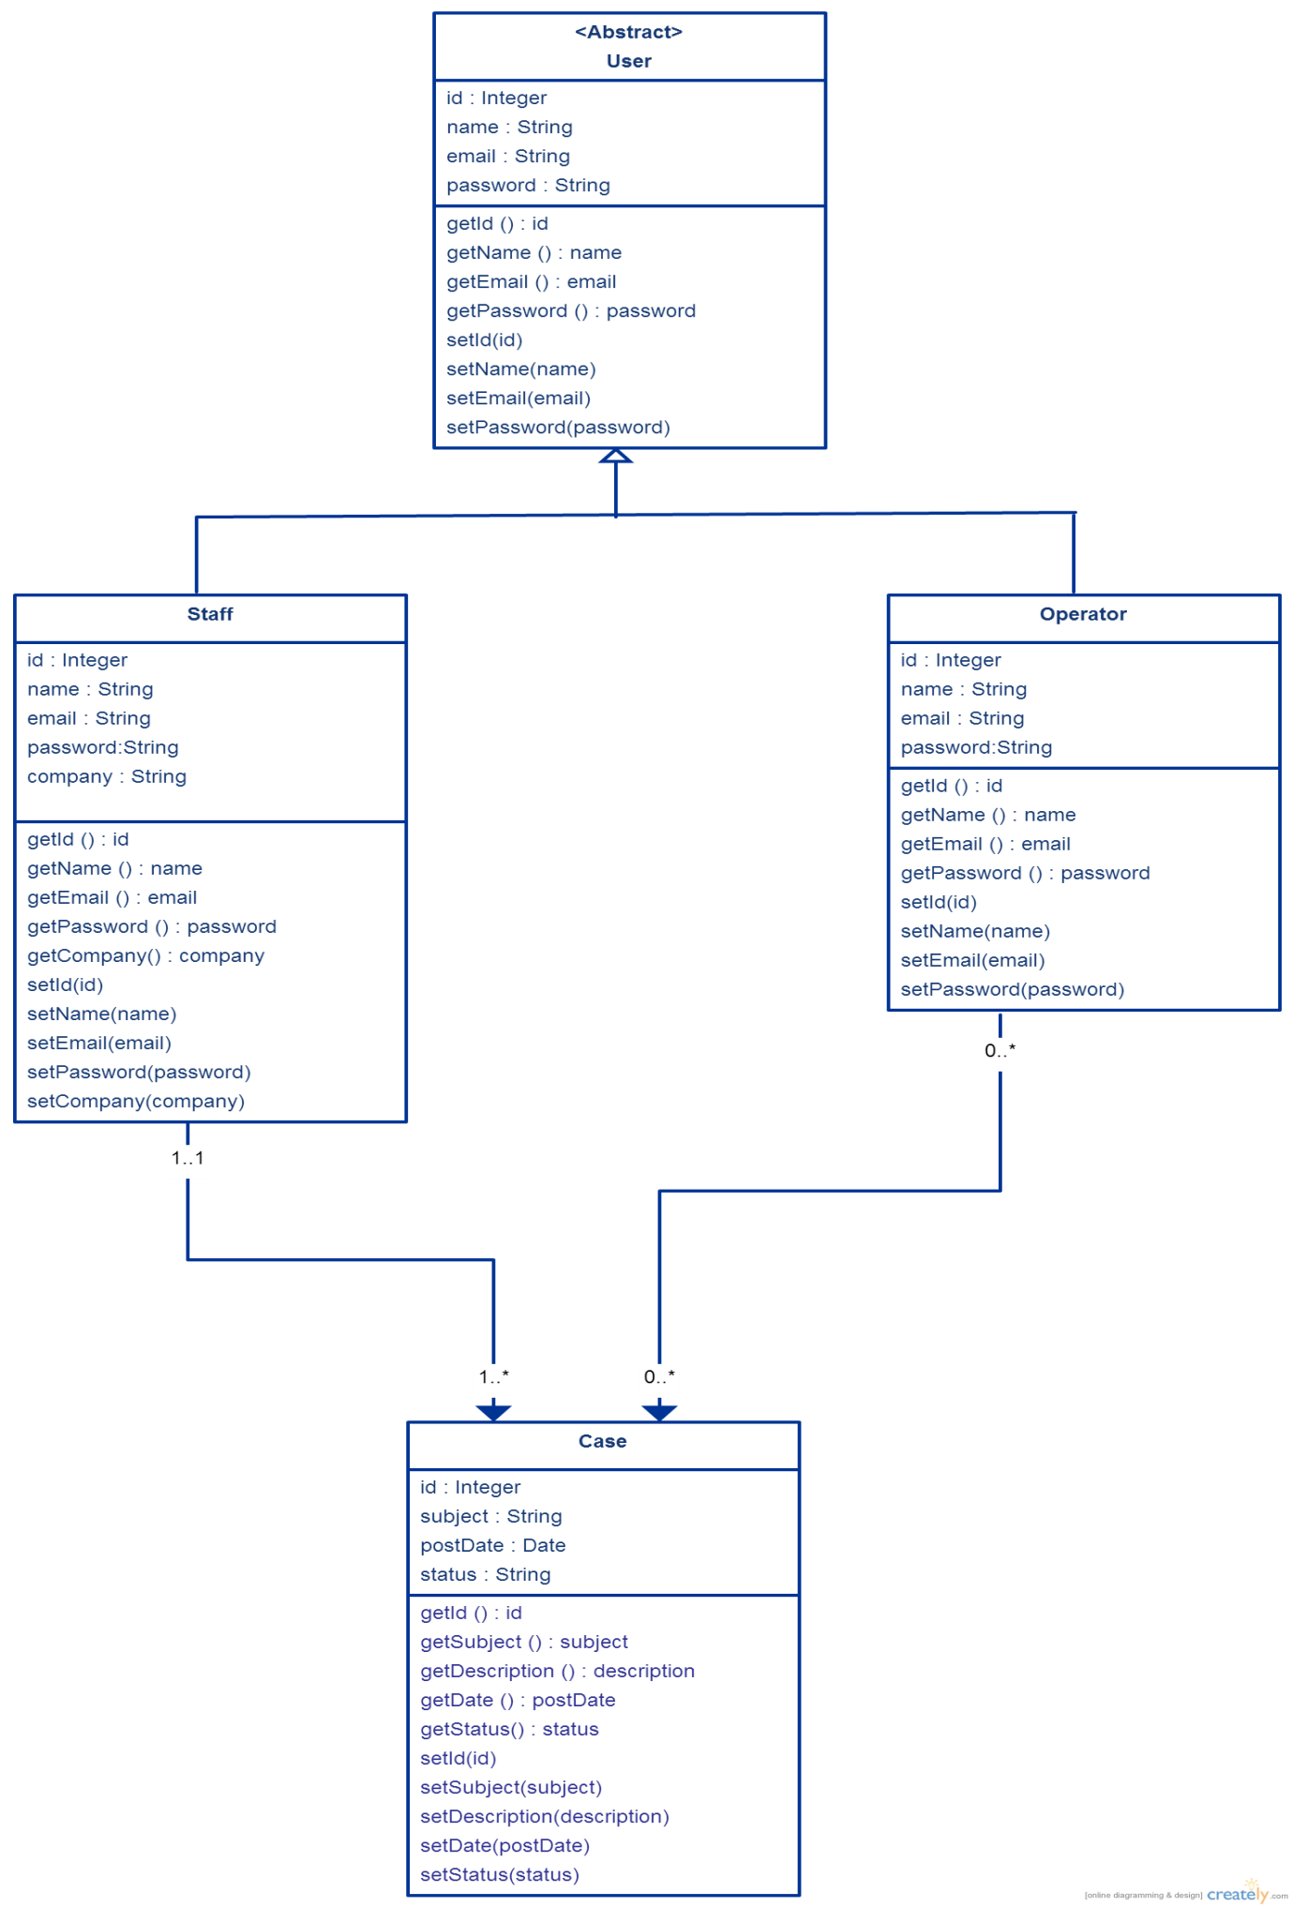

## Enhancement to existing system

The improvement system will be design as a new application mainly used by the casino. This system provides an easy to learn interface for casino staff which problem reports can be type in a text box without open the SugarCRM or Excel file. Data input to this system will be transfer to another Excel automatically and then transfer into the SugarCRM. Rapidly occurs problem information will be group together and the number of similar problem occurred will be shown in the SugarCRM interface too. This reduce the complex process of doing a report from the staff to the SugarCRM system because all the staff need to do is type the same simple description into this application and send it out. It looks difference with the pass way staff do, but once a report is sent, information will be as send into the SugarCRM system as well. In the pass, after the staff sent a problem report, data entry operator in LT Game need to input it back to the SugarCRM one by one which is really inefficient. In addition, once a problem is reported, E-mail will be also sent to the manager. Of course, rapidly occurred problem reports will be group together and if the same case occur over 10 times in a day a warning message will be also sent to the manager’s cell-phone. This application will be a combine of add function and the existing SugarCRM which will have a great improvement for managers.

## Key problems and their solutions

During the implementation process, some problems occurs. For example, since the (……. Technical problems……). Besides technical problems, the project also met problem in installing into the LTGame’s system. To install this enhance CRM needs authorization from the manager in LTGame. Also, problem occurred in promoting this new CRM to casino manager and IT technician as they are unwilling to learn a new system. Also, a lot of managers are unwilling to spend time to have an extra training. Therefore, the importance of using this new CRM is explained to them so that they would attend the training section and learn how to use it effectively.

# Results and discussion

## Project Outcome

After implementation, this section will show the outcome of the project.

In the whole process, we firstly select one person as a representation to go to the LTGame and become a part of its staff to use the SugarCRM. After using the system in three months, a list of problems are indicated. After one week, all the members in this project sat together and have a meeting with LTGame. In the meeting, most of the requirements are discussed and in the next week all the requirements are listed in a document. In the next two weeks, plan and analysis processes are done and the project move on to the implementation. Base on the requirements, a prototype of the enhance CRM is proposed. In the enhance CRM, most of the main functions in SugarCRM used by LTGame is also presented and added functions following the requirement is also implemented. And now the new CRM system is much more powerful function and a much more user-friendly interface.

In this enhanced CRM system, functions in SugarCRM like input reports, list all the reports, etc. are presented in the system as well. Also, following the requirements, for client now they can do the following actions:

**Casino floor manager:**

* Create new account for IT support member
* Import account by using system template.
* Change account information under his/her group

**Casino IT support:**

* Login their own account
* Report new cases
* Select the priority of the case

**LTGame manager:**

* Create new account
* View all the created accounts in group of casinos.
* View all the reported cases
* Change case status
* Search case
* Sort search results by case name, status, subject, people to assign, account name, priority

**For all Client:**

* Run on windows and MAC os
* Respond time is about 1.5 seconds
* Bio-language interface with English and Chinese
* Change display language in option
* Register into the system
* Use e-mail front name as the account name

**For server:**

* Run on windows and MAC os.
* Run for 24-hour
* Do maintenance with a copy of all the data in server database
* Update maintained data in 2 minutes
* Check not yet closed case
* Send warning to LTGame manager, casino floor manager and casino IT support for not yet closed cases last for over a week

After implemented this prototype, we send it to LTGame and let staff in there have a try. After a week, some feedback are received, and……..

## System evaluation

With the prototype some tests are also done to evaluate system performance.

For doing user testing, the system is distribute to users use it. After a few weeks, some feedback are received from the users. Over 80% users consider this enhance CRM is useful. Most of these user also said it is easy to learn the new CRM. Some feedback for future improvement such as (… ) are also received.

# Appendix

## Project plan

Gantt Chart

# Refernces

[1] LTGame web page. <http://www.ltgame.com/about.aspx>.[Sep. 10, 2014]

[2] SugarCRM company web page. <http://www.sugarcrm.com/>.[Sep. 10, 2014]

[3] Talkincloud. <http://talkincloud.com/sugarcrm-wins-ibms-crm-business-ibm-unveils-new-bi-tools>. [Sep. 10, 2014]

## Peer Assessment Form

|  |  |  |  |  |  |  |
| --- | --- | --- | --- | --- | --- | --- |
| S:\3rd ITC\2nd ITC\MPI_logos\MPI logo09_C349 CPE.tif  BSc. in Computing 2013/14  COMP321 Information System Implementation  Peer Assessment Form | | | | | | |
| Group number |  | | | | | |
| Group members | |  |  |  | | --- | --- | --- | |  | Student ID | Student name | | *1.* |  |  | | *2.* |  |  | | *3.* |  |  | | *4.* |  |  | | 5. |  |  | | | | | | |
| Contribution **(**Each row must total to 100%) | | | | | | |
|  | | Member 1 | Member 2 | Member 3 | Member 4 | Member 5 |
| 1. Project leadership | | % | % | % | % | % |
| 2. Data modeling | | % | % | % | % | % |
| 3. User interface design | | % | % | % | % | % |
| 4. Program development | | % | % | % | % | % |
| 5. Solving technical problems | | % | % | % | % | % |
| 6. Testing and sample data | | % | % | % | % | % |
| 7. Report writing | | % | % | % | % | % |
| 8. Preparing / giving presentation | | % | % | % | % | % |

By default, the eight items above have the same weight when calculating the overall contribution percentage. You are welcome to suggest different weight if you consider some aspects should carry more weight.